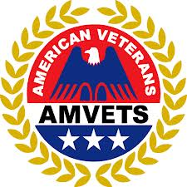
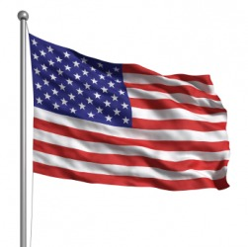

AMVETS

American Veterans
Certificate of Good Standing

TN-Dept
This certificate is presented by AMVETS National Headquarters in recognition of your Departments good standing in AMVETS. Your Department revalidation for 2022-2023 is on record meeting the requirements set forth in the AMVETS Constitution and Bylaws, Your Department is current in all federal requirements for a 501C19 nonprofit organization. Your Department earned this letter of good standing by adhering to the requirements stated in our Congressional Charter, public law 216.

“To establish facilities for the assistance of all veterans”

AMVETS National Headquarters

Veterans in service to America

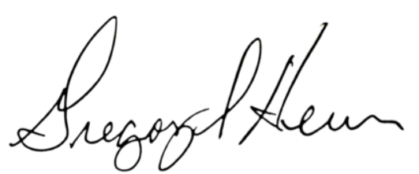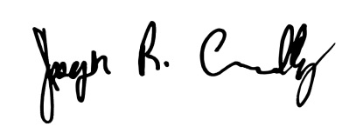
Gregory Heun, National Commander Joseph Chenelly, Executive Director

